|  |  |  |  |  |  |  |
| --- | --- | --- | --- | --- | --- | --- |
| http://www.triumf.ca/sites/default/files/TRIUMF_logo_black.jpg | | |  | Document-132994 | | |
| Design Note TRI-DN-16-11  UCN Kicker Control and Diagnostics | | | | | | |
|  |  | | | | | |
| **Document Type:** | **Design** **Note** | | | | | |
| **Release:** | **DRAFT** | **Release Date:** | | | **2016/06/01** | |
| **Author(s):** | **Thomas Lindner** | | | | | |
|  |  |  | | | |  |
|  | **Name:** | **Signature:** | | | | |
| **Author:** | **Thomas Lindner** | **APPROVAL RECORD** | | | | |
| **Reviewed By:** | **Cam Marshall** |
| **Des Ramsay** |
| **Violeta Toma** |
| **Rod Nussbaumer** |
| **Daryl Bishop** |
| **Approved By:** | **Larry Lee** |

History of Changes

*Note: Before using a copy (electronic or printed) of this document you must ensure that your copy is identical to the released document, which is stored on TRIUMF’s document server.*

|  |  |  |  |
| --- | --- | --- | --- |
| Release Number | Date | Description of Changes | Author(s) |
| #01 | 2016/06/01 | Initial release | Thomas Lindner |
|  |  |  |  |
|  |  |  |  |
|  |  |  |  |

**Keywords:** list of keywords

**Distribution List:** list of names

# Introduction

During operation of the Ultra-Cold Neutron facility, beam will be shared between the existing meson hall users (beamline 1A) and the new UCN line (beamline 1U). The UCN line is designed to take up to one-third of the total current, for example 40 μA to UCN and 80 μA to the meson hall, as shown here:

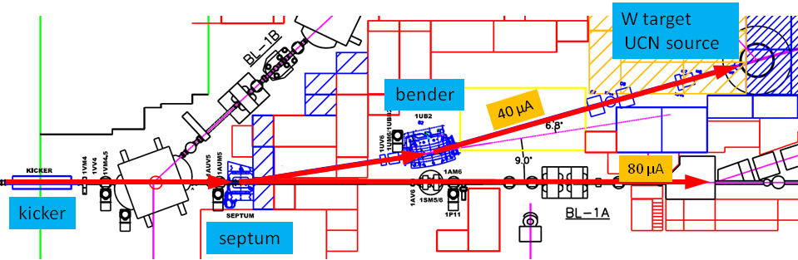The beam from the cyclotron is delivered in 1 ms “buckets” separated by shorter periods where the beam is blanked by the ion source pulser. During UCN operation the blanking interval will be required to be 50 μs or longer (normally in the range 50 μs to 100 μs). Beam sharing will be done by deflecting a certain fraction of the beam buckets to UCN. For the 2:1 split shown below, 1 bucket is deflected to UCN, 2 buckets allowed to pass undeflected, and so on.

Figure 1: UCN beamline.

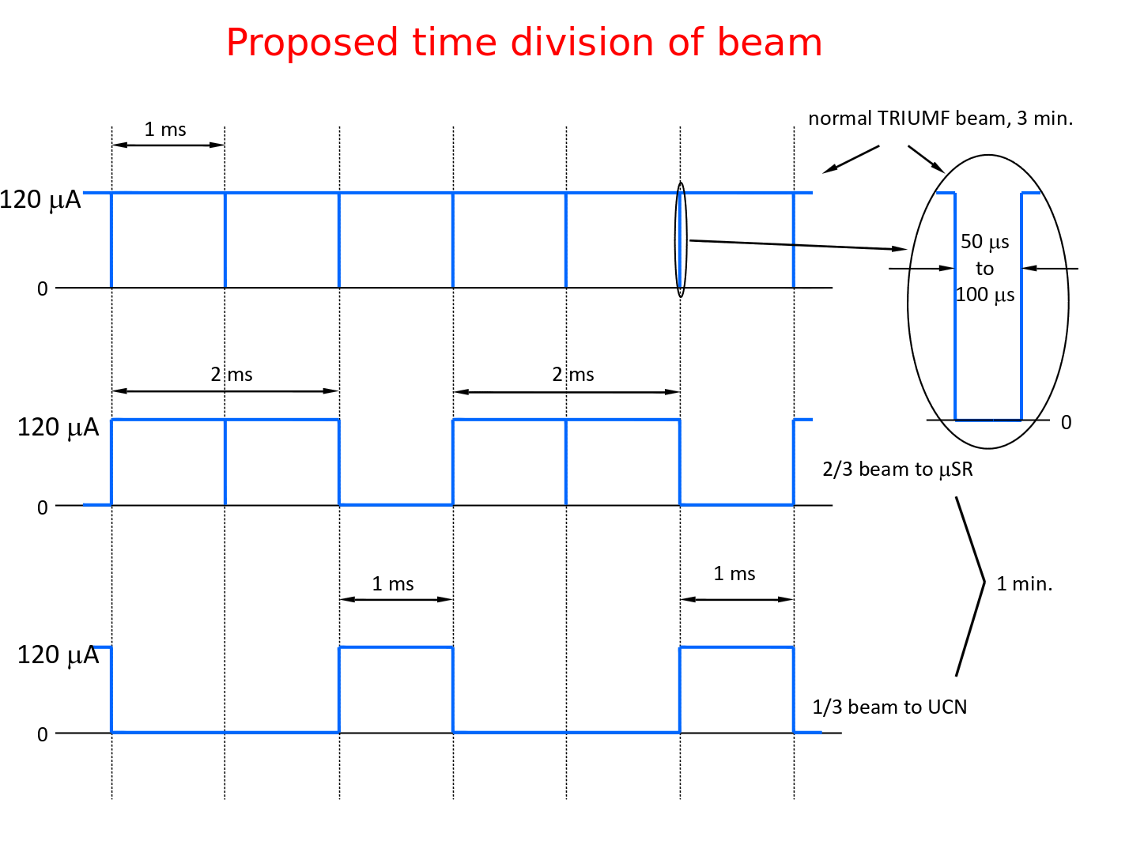

Figure 2: Scheme for dividing beam between beamline 1A and 1U. In final configuration 1/3 of beam buckets go to 1U. Note the kicker magnet must ramp up and down within the blanking notches.

To deflect a beam bucket to UCN, the kicker magnet ramps up during the 50 μs blanking interval, deflects the bucket to the UCN beamline, then ramps down again in the 50 μs blanking interval following the beam bucket.

The Kicker control must deliver a signal synchronized with the arrival of the beam blanking notch at the kicker. Since the beam takes approximately 330 μs to travel from the ion source to extraction, and the time can vary by some tens of μs depending on the machine tune, it is necessary to have a suitable beam current monitor near the kicker. This is provided by the 1VM4 capacitive beam monitor located just downstream of the kicker (see “UCN Kicker Time Pickoff” below). The kicker control system can use the 1VM4 signal to confirm that the kicker trigger is aligned to the real beam notch at the kicker magnet.

It is also important to measure the amount of beam present during the blanking notch. During this time, the beam sweeps from the straight-through port of the septum magnet to the magnetic field section that deflects the beam to UCN (see picture in appendix). If any beam is present during the sweep, it will hit the steel of the septum. The slower the beam sweeps, the more will be spilled on the septum. Assuming the slowest of 50 μs for the full sweep, the beam will cross the septum steel and beam pipe wall during the time from 18 μs to 32 μs after firing the kicker. In this interval the beam current should be below 430 nA to limit the spill onto septum to 1 nA averaged over the UCN cycle. If the beam monitor indicates notch contamination exceeding this limit, we can blank the kicker trigger and not kick until the contamination is once again under the limit. For good signal to noise ratio, the 430 nA limit based on long term beam spills could be measured with several seconds of averaging. Spills large enough to cause a radiation trip of the cyclotron will be detected by the nearby TRIUMF beam spill monitors.

Finally, it should be noted that these short kicker cycles (ramping up to spill one bucket onto UCN target, ramping down to send two buckets to beamline 1A) is superimposed onto a longer UCN cycle, where we want to put beam onto the UCN target for 1 minute (to produce UCNs) and then have a 3 minute period to do measurements of the UCNs. This 1-minute ON, 3-minute OFF cycle would then be continuously repeated in final UCN operations.

We will start this note by listing the expected modes of UCN beamline operation. We will then describe the proposed control system to allow this operation.

One final point: this document does largely not deal with the questions of machine protection associated with UCN beamline operation; that issue will be dealt within another document. The only exception to this is that our measurement of the 1VM4 signal will provide protection against two failure modes (mistimed kicks and dirty beam blanking periods); we will describe that system in this note.

# Summary of UCN Beamline Operating Modes

As noted above, in its final configuration, we expect to operate in a mode where we kick one out of each three beam buckets to UCN for 1 minute, then stop kicking for 3 minutes. However, there will be a number of different stages of operation before we get to that point. The following is a list of the expected operating modes:

* Beam optics commissioning: kicker magnet will be in ‘DC mode’ where all 1V beam is directed down beamline 1U; the kicker magnet will be essentially a bending magnet in this case. This also means that we will be in single user mode, with no beam getting directed to 1A. We will want to direct very small (~nA) beam current to UCN target.
* First cold neutron production: kicker magnet will be in ‘DC’ mode, with 1U in single user mode. In this case we will want ~1uA of beam to UCN target.
* UCN source commissioning: kicker magnet will be in regular kicking mode, where we kick a fraction of beam buckets to 1U; beamline 1A experiments will get most of the beam. We will start by requesting ~1uA of average beam to 1U; this means that we will kick 1 beam bucket out of 120 (assuming 120uA overall beam current). Sometimes we will request continual beam on target. Other times we will request either a single 1 minute period of beam or repeating cycles of 1 minute ON / 3 minute OFF.
* As the UCN source gets fully commissioned we will gradually increase the beam onto UCN target to 40uA (kicking 1 in 3 buckets, rather than 1 in 120) and more regularly run in the 1min ON/3min OFF cycle.

# Overview of Kicker Control System

Given the context described above, the proposed kicker control system is shown below:

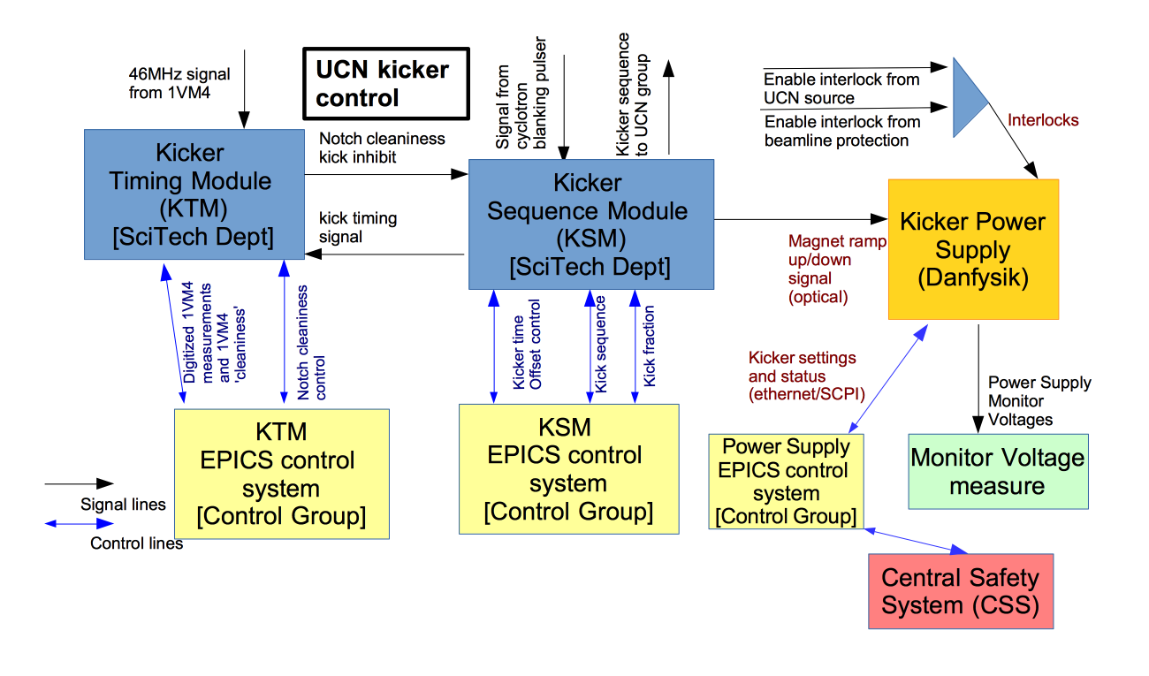

Figure : Proposed system for controlling kicker magnet.

The main components of the control system are:

1. Power supply EPICS control system: this system would provide the EPICS control of the kicker magnet power supply; this would be used by cyclotron ops to configure the magnet. This system will also connect to the CSS system.
2. Kicker Sequence Module (KSM): this custom designed electronics module would handle the following:
   1. Creating a kick signal; i.e. adding a fixed delay to the signal from the cyclotron blanking pulser.
   2. Creating the short and long timescale sequence of kicks.
   3. Actually ramping the magnet.  
      We assume that the hardware and firmware for this module would be provided by the Science Technology department. It may be possible to use an existing module for the hardware.
3. KSM EPICS control system: this system would provide the EPICS control of the kicker sequencing.
4. Kicker Timing Module (KTM):
   1. Digitizing the signal from the 1VM4 capacitive beam monitor.
   2. Making a decision about whether the kick signal is well aligned with the notch and notch background is sufficiently low.

We assume that the hardware and firmware for this module would be provided by the Electronics Development group.

1. KTM EPICs control system: this system would provide the EPICS control of the 1VM4 digitization and the kick inhibit.  
   We assume that the EPICS components would be handled by the controls group.

We will describe these modules more below, as well as describing the 1VM4 signal.

Note that you see in the diagram the signals that provide the interlock of the kicker magnet operation; as noted, the design of those interlock systems will be described in a different note.

# Danfysik Power Supply EPICS Control System

The EPICS control system would provide control, readbacks, status alarms and archiving of all process variables (sampling rate to be defined) of the actual kicker power supply to the cyclotron operations group. Danfysik provided a detailed user manual for power supply; a link to the manual is given at the end of this document.

**Remote configuration and monitoring of the power su**pply is provided through an Ethernet interface, using the SCPI protocol. Table 4 (page 27) of the power supply manual provides all the available SCPI commands. I would imagine that the EPICS control should provide access to all the listed configuration options and read-back information.

This EPICS system will also need to provide information to the Central Safety System (CSS); in particular, the EPICS system will need to pass along the information if the magnet reports any error condition to the CSS; CSS will need to know the status of this magnet before it allows sending beam along 1A.

# Kicker Sequence Module (KSM)

This module is in charge of creating the sequence of kicks that will actually drive the kicker power supply. Figure 4 shows the logic inputs/outputs from this module, as well as the VME control interface are shown below.

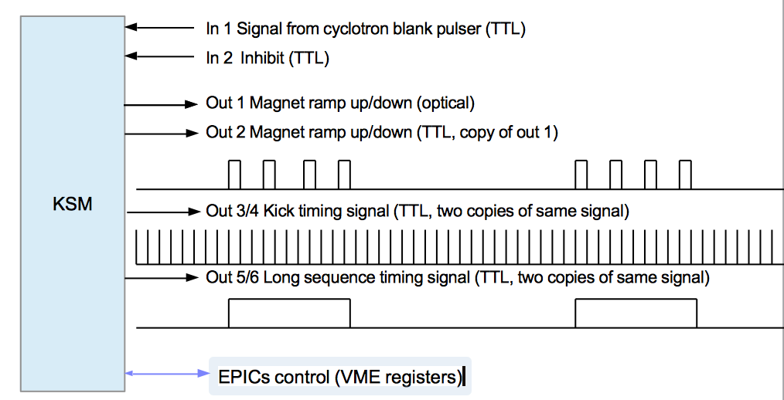

Figure : Logical inputs and outputs of KSM.

For the KSM hardware we have converged on using an existing VME module called a PPG (Programmable Pulse Generator) which was developed by the electronics development and DAQ groups and is used by a number of experiments around TRIUMF. New firmware will need to be developed for the PPG, but the existing hardware should satisfy the KSM requirements. (Note the PPG does not have an optical output. We will use an external TTP->optical adaptor. Daryl already seems to have some of these.)

The KSM would start by defining the time at which the magnet kick should start. This time would be defined by adding a fixed offset to the time from the cyclotron blanking pulser signal (input 1). The operator would need the ability to change the time offset of the kick signal (parameter PULSER_OFFSET). A copy of this **adjusted kick time** would be available on outputs 3 and 4.

The KSM would then define the actual short term and longer term sequence for the kicker magnet; i.e. define the short term cycle of kicking of a fraction of the beam buckets and the longer 1 min. beam-on / 3 min. beam-off cycle for normal operation. As mentioned earlier, there would need to be a large number of different modes and configurability in defining the longer term sequence. For a starting point we would want the ability to operate the KSM and kicker with the following different modes:

1. Operate the kicker magnet to permanently on so all beam gets directed to BL1U (parameter KICKER_DC_MODE). This would mean setting the magnet output (output 1) to permanent high.
2. Operate the kicker magnet where we kick a fraction (parameter KICK_FRACTION) of beam buckets to beamline 1U. It would repeat kicking a fraction of buckets for a configurable ON period (parameter BEAM_ON_PERIOD) then shut off magnet for a configurable OFF period (parameter BEAM_OFF_PERIOD). It would repeat these ON / OFF periods for a configurable number of **long cycles** (parameter NUM_LCYCLES).
3. Operate the kicker magnet in a manner identically to 2, except that the ON/OFF cycles would continue forever (parameter BEAM_CONTINUOUS_CYCLE).

The **sequences** in modes 2 and 3 would be started by writing to a VME register (START_SEQUENCE). We show a diagram showing a mode 2 or 3 sequence in Figure 5.

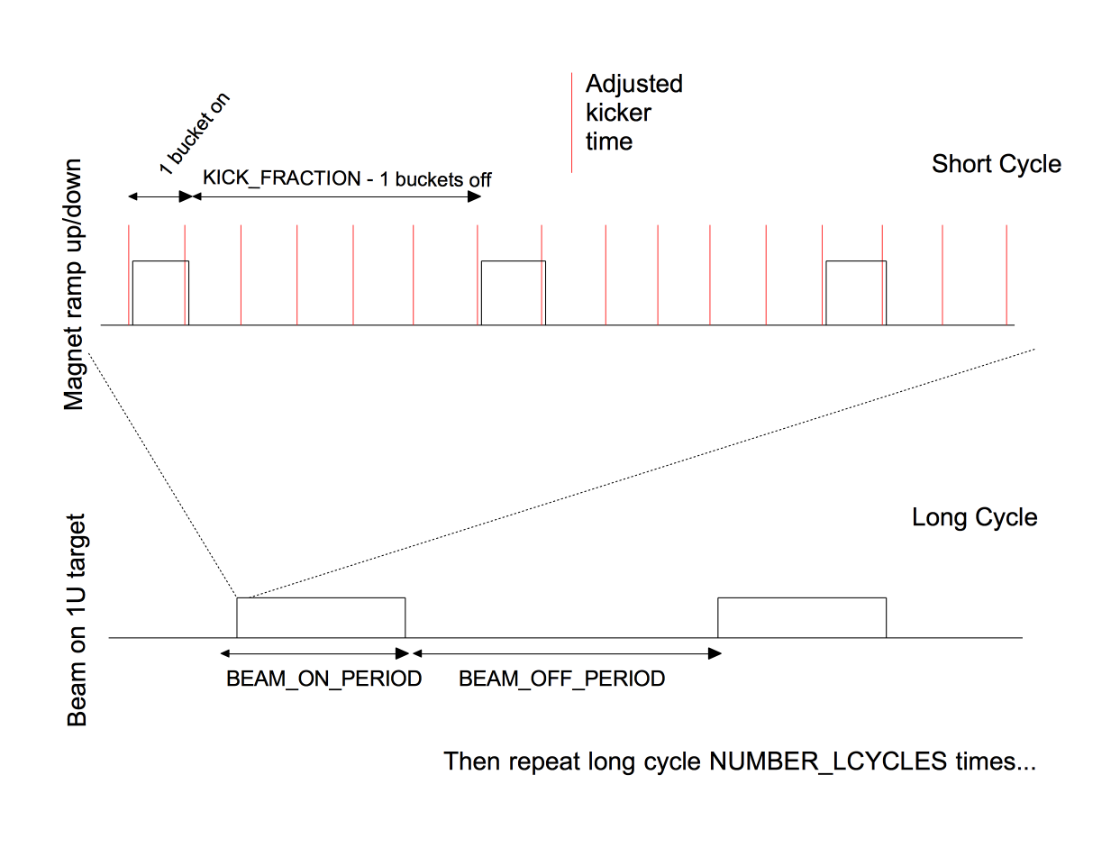

Figure : Diagram of short and long kicker cycles. In this example we are kicking 1 out of each 6 beam buckets.

Below we show the proposed list of VME parameters that would control the above operation.

Table 1: List of VME Parameters

|  |  |  |
| --- | --- | --- |
| VME Parameter Name | Parameter Function | Type ; unit |
| KSM_ENABLE | If set to 1, then the KSM can start kicker sequences or set kicker in DC mode  If set to 0, then the KSM will not operate magnet (ie, output 1 will not go high). | r/w ; n/a |
| KICKER_DC_MODE | Setting this parameter to 1 will turn on the kicker magnet permanently, ie set output 1 high. | r/w ; n/a |
| PULSER_OFFSET | Fixed offset to add to cyclotron blanking pulser before subsequent operations | r/w; Clock units (10ns) |
| KICK_FRACTION | Defines fraction of beam buckets kicked to beamline 1U. Specifically, means we will kick one bucket to 1U and then let KICK_FRACTION-1 buckets go to beamline 1A; so 1/KICK_FRACTION buckets will go to 1U. | r/w ; n/a |
| BEAM_ON_PERIOD | Defines length of beam ON period (with fraction of buckets going to UCN) | r/w; milliseconds |
| BEAM_OFF_PERIOD | Defines length of beam OFF period (with no beam going to UCN) | r/w; milliseconds |
| NUM_LCYCLES | The number of ON/OFF cycles to perform before stopping | r/w; cycles |
| BEAM_CONTINUOUS_CYCLE | Writing 1 to this register would set the KSM to use a continuous (never ending) sequence. Writing 0 would mean a cycle ends after NUM_LCYCLES. | r/w; n/a |
| START_SEQUENCE | Writing 1 to this register would start the magnet kicks. This would have no effect if a sequence is already in progress.  Writing 0 to this register would stop any ongoing sequence.  Register has no effect in DC mode. | r/w ; n/a |
| KSM_STATUS | Bit 0 : is magnet on Bit 1 : is in sequence Bit 2 : is KSM inhibited Bit 3 : | r/o; bit-field |
| CYCLE_STATUS | Number of cycles executed since sequence started. | r/o ; bit-field |
|  |  |  |

The KSM will also have an inhibit input. If the inhibit input goes high then the KSM should immediately ramp down kicker magnet (if it is on) and stay down.

Additionally, the KSM should have some logic where the magnet will always get ramped down after 2 ms (unless in DC mode). This will protect against a situation where the KSM ramps the magnet up on one blanking notch, but the signal from the blanking notch then goes away (for whatever reason).

We will also provide a more complete KSM manual that describes the precise behavior of the as-built KSM firmware. The link for this KSM manual is listed in the related documents.

# KSM EPICS Control System

The EPICS control system would provide control, readbacks, status alarms and archiving of all process variables (sampling rate to be defined) of the KSM to the cyclotron operations group. Important parts of this control would include:

1. Enabling the KSM for operation.
2. Configuring the sequencing that will be controlled by the KSM module.
3. Starting a particular sequence or setting the kicker to DC mode.

One point that is worth explaining in detail is how we propose to set the fixed offset that the KSM will add to the cyclotron blanking notch signal. The procedure for setting this offset will be

* get a rough idea of the offset by looking at the measured transit time of the protons through the cyclotron.  Set the KSM module offset to this rough estimate of transit time.
* refine the offset by comparing the 'kick timing signal' from the KSM to the measured notch position from the 1VM4 signal.  One important feature for the KSM would be that it would need to put out this 'kick timing signal' even when it was not actually kicking, so that it could be used for this adjustment.

In the long run the operator would be able to make this comparison (between the 1VM4 signal and the kick timing signal) in the EPICS display of the KTM data.  For the commissioning in the fall we might have to make the refinement using a scope or some other temporary digitization of the 1VM4 signal.

# UCN Kicker Time Pickoff

The TRIUMF beam has a microstructure of bursts a few nanoseconds wide separated by 43 nanoseconds (RF frequency 23 MHz). The kicker time monitor is a capacitive pickoff, 1VM4, located just downstream of the kicker. The pickoff is sensitive to the 23 MHz microstructure. The raw signal is fed to a broadband preamp followed by a tuned second stage operating at the second harmonic, 46 MHz. The output of the tuned stage is a 46 MHz sine wave whose envelope follows the beam current. The bandwidth of the second stage can be adjusted to trade settling time against noise (low noise = long settling time). It is now set to settle (several 1/e time constants) in 1 μs. At this time constant, the electronic noise is 0.15 μA. The monitor and front-end electronics are already in place.

The electronics handles beam currents of 0 μA – 120 μA. The input is triax cable from the capacitive pickoff and the output is normal Coax. Leonid Kurchaninov has the details. We have to use the signal from the time pickoff to confirm that the kicker signal is synchronized with the arrival of the beam at the kicker, and to prevent kicking if the contamination in the beam-off-notch is too high.

# Kicker Timing Module (KTM)

The first task of this module is to digitize the signal from the tuned 1VM4 signal. We would start by demodulating the 46 MHz signal down to a signal with 1us variations. We would then digitize the signal with a sampling of 0.5-2.0 MHz. The digitized signal should clearly show the 50 μs notches in which we want to kick the magnet.

The module would then analyze the digitized 1VM4 signal in order to determine how much beam background was present in the magnet ramping period. It would use the kick timing signal from the KSM to define when the ramping period starts; the kick timing signal is just the beam notch signal with a modifiable offset. In order to get good signal to noise the module might need to average a number of notches before measuring the beam background. The operator will need to specify a limit for the beam background. Based on the results of the analyzed 1VM4 signal the KTM would be able to inhibit the KSM if the 1VM4 shows misaligned or unclean blanking notches.

For diagnostic purposes we would also want to have a way of reading out and examining the digitized 1VM4 signals.

In the longer term, we may also want to consider a system where the KTM can modify the proposed kick time, based on the measured 1VM4 signal (some sort of phase-lock loop).

Challenges for KTM: it may be hard to accurately measure the blanking notches if the cyclotron is running at low beam power.

# KTM EPICS Control System

The EPICS control system would provide control, readbacks, status alarms and archiving of all process variables (sampling rate to be defined) of the KTM to the cyclotron operations group, as well as providing a diagnostic picture showing the digitized 1VM4 signal around the blanking notch And the beam background during magnet ramp up.

# Kicker Power Supply Monitor Voltages

The kicker power supply provides a set of analog signals that follow the input/output current and voltages provided by power supply. We may want to monitor these signals or use them to provide some additional system interlocks. Implement alarms for power supply off and out of range. Archive voltage/current

# Staging and Timeline of Work Request

We would suggest that the kicker control work be staged as follows:

* Stage 1: the controls groups would only implement the control functionality of the magnet power supply; this would allow for the operation of the kicker magnet in ‘DC mode’, i.e. where all the beam was directed to 1U during summer 2016.
* Stage 2: the SciTech and controls groups would only implement the control functionality of the KSM module. The KSM module is the critical piece necessary to actually operate the kicker in its regular, kicking mode; having this module would allow for earlier commissioning of the UCN beamline in fall 2016 -
  + In stage 1 and 2 we would manually monitor the 1VM4 signal using a scope or some other commercial digitizer, but would not require any automatic feedback from the 1VM4 measurement to the KSM. This would allow us to make better measurements of the 1VM4 signal and confirm how best to digitize and analyze it.
* Stage 3: based on the results of the first stage, the edev and controls groups would then create the KTM module. This would happen in 2017. This would mean that we run without automatic checks of the blanking notch timing from the KTM; but we will still have machine protection provided by the BSM detectors that would see beam spilled onto the septum magnet.

# Related Documents

For reference, see additional documents on –

UCN kicker power supply user manual (from Danfysik)

<https://ucn.triumf.ca/triumf/magnets/kicker/User%20Manual-%20CAN501996-201%20TRIUMF%20UCN%20Kicker%20MPS.pdf/view?searchterm=User%20manual>

Kicker Sequence Module (KSM) Manual:

**Appendix:**

